**Forest Fire Prediction Using Machine learning Technique**

**Abstract:**

Forests are an essential natural resource to humankind, providing a myriad of direct and indirect benefits. Natural disasters like forest fires have a major impact on global warming and the continued existence of life on Earth. Automatic identification of forest fires is thus an important field to research in order to minimize disasters. Early fire detection can also help decision-makers plan mitigation methods and extinguishing tactics. This research tells us the early detection of forest fires using rainfall, humidity wind speed, fine fuel moisture code, duff moisture code, drought code and fire weather index. So by using the dataset we had, we develop a model to predict early forest fire prediction.

**Existing System:**

Fires caused in forests are known to be one of the most hazardous environmental issues which cannot be neglected. Fast and quick prediction is the only way by which we can at least face it with readily available fire extinguishing resources. To accomplish this one of the best ways is to use automatic tools based on locally placed sensors, such as rain, thermal readings, relative dampness and wind. In this work, we inquire a Data Mining (DM) approach to predict the area prone to forest fire. SVM (Support Vector Machine) algorithm is used for live sensor data. SVM algorithm utilizes four sensor inputs related to weather info data (i.e. thermal data, relative dampness, rain and wind velocity) and it is feasible to predict the burned land zone due to small fires, which are periodic or frequent. Awareness about those zones are utilized for developing and deploying fire fighting resource management. The data received from the sensor devices are processed in individual fog nodes and the cumulative data is collected upon and is used for further analysis. The data transfer happens wirelessly via Zig-Bee tool. The results obtained is utilized to predict the areas which are prone to and will be affected by sudden outburst of forest fire.

**Drawbacks**

* They are using machine learning with less parameters
* The implementing algorithm shows low accuracy.
* They have not mentioned any metrics reports.

**Introduction:**

Crop yield prediction is one of the challenging tasks in agriculture. It plays an essential role in decision making at global, regional, and field levels. The prediction of crop yield is based on soil, meteorological, environmental, and crop parameters. Decision support models are broadly used to extract significant crop features for prediction. Precision agriculture focuses on monitoring (sensing technologies), management information systems, variable rate technologies, and responses to inter- and intravariability in cropping systems. The benefits of precision agriculture involve increasing crop yield and crop quality, while reducing the environmental impact.

**Preparing the dataset:**

This dataset contains 2201 records of field test with their mineral details, pH, temperature, humidity and rainfall along with the type of crop growing in such condition.

## PROPOSED SYSTEM:

The proposed system will predict the most suitable crop for particular land based on soil contents and weather parameters such as Temperature, Humidity, Soil PH, Nitrogen, Phosphorus, and Rainfall. Data collection is the most efficient method for collecting and measuring data from different resources. After collecting datasets from various resources, the dataset must be preprocessed before training to the model. The data preprocessing can be done in various stages, beginning with reading the collected dataset the process continues to data cleaning. In data cleaning the datasets contain some redundant attributes, those attributes are not considered for crop prediction. So, we have to drop unwanted attributes and datasets containing some missing values. we need to drop these missing values or fill them with unwanted nan values in order to get better accuracy. Statistical algorithms and machine learning techniques to identify future outcomes based on historical data. The goal is to go beyond knowing what has happened to provide the best assessment of what will happen in the future. In our system, we used a supervised machine learning algorithm having subcategories as classification and regression. The classification algorithm will be most suitable for our system.

**Advantages:**

* We are using the machine learning technique for getting better predictions.
* More than two machine learning algorithms are compared.
* They didn’t calculate the accuracy and performance metrics.
* Deployment is done here.

**LITERATURE REVIEW:**

**General**

A literature review is a body of text that aims to review the critical points of current knowledge on and/or methodological approaches to a particular topic. It is secondary sources and discuss published information in a particular subject area and sometimes information in a particular subject area within a certain time period. Its ultimate goal is to bring the reader up to date with current literature on a topic and forms the basis for another goal, such as future research that may be needed in the area and precedes a research proposal and may be just a simple summary of sources. Usually, it has an organizational pattern and combines both summary and synthesis.

A summary is a recap of important information about the source, but a synthesis is a re-organization, reshuffling of information. It might give a new interpretation of old material or combine new with old interpretations or it might trace the intellectual progression of the field, including major debates. Depending on the situation, the literature review may evaluate the sources and advise the reader on the most pertinent or relevant of them

**Title:** Data mining approach to predict forest fire using fog computing

**Author:** Aakash Rajagopal S

**Year:** 2018

Fires caused in forests are known to be one of the most hazardous environmental issues which cannot be neglected. Fast and quick prediction is the only way by which we can at least face it with readily available fire extinguishing resources. To accomplish this , one of the best ways is to use automatic tools based on locally placed sensors, such as rain, thermal readings, relative dampness and wind. In this work, we inquire a Data Mining (DM) approach to predict the area prone to forest fire. SVM (Support Vector Machine) algorithm is used for live sensor data. SVM algorithm utilizes four sensor inputs related to weather info data (i.e. thermal data, relative dampness, rain and wind velocity) and it is feasible to predict the burned land zone due to small fires, which are periodic or frequent. Awareness about those zones are utilized for developing and deploying fire fighting resource management . The data received from the sensor devices are processed in individual fog nodes and the cumulative data is collected upon and is used for further analysis. The data transfer happens wirelessly via Zig-Bee tool. The results obtained is utilized to predict the areas which are prone to and will be affected by sudden outburst of forest fire. Keywords—Internet of Things (IoT), Fog based computing, Canadian Forest Fire Index, Support Vector Machine (SVM).

**Title:** Artificial Intelligence for Forest Fire Prediction

**Author:** George E.Sakr, Imad H. Elhajj, George Mitri and Uchechukwu C. Wejinya

**Year:** 2010

Forest fire prediction constitutes a significant component of forest fire management. It plays a major role in resource allocation, mitigation and recovery efforts. This paper presents a description and analysis of forest fire prediction methods based on artificial intelligence. A novel forest fire risk prediction algorithm, based on support vector machines, is presented. The algorithm depends on previous weather conditions in order to predict the fire hazard level of a day. The implementation of the algorithm using data from Lebanon demonstrated its ability to accurately predict the hazard of fire occurrence. Index Terms Machine Learning, SVM, Forest Fire Prediction.

**Title:** PREDICTING FOREST FIRES WITH DIFFERENT DATA MINING TECHNIQUES

**Author:** Madhurima De, Linika Labdhi, Bindu Garg

**Year:** 2020

Forest fires are one of the most frequently occurring disasters in recent years. The behaviour of forest fire and its severity result from a combination of factors such as available fuels, physical setting, and weather. Analysis of historical meteorological data and national fire records in western North America show the primacy of climate in driving large regional fires via wet periods that create substantial fuels, or drought and warming that extend conducive fire weather. The effects of forest fires creates a very lasting impact on the environment as it leads to deforestation and global warming, which is also one of its major cause of occurrence. Forest fires are dealt by collecting the satellite images of forest and if there is any emergency caused by the fires then the authorities are notified to mitigate its effects. In this work, we will be exploring various Data Mining (DM) approaches to predict the burnt area of forest fires. Five different DM techniques, e.g. Support Vector Machines (SVM) and Random Forests, and four distinct feature selection setups (using spatial, temporal, FWI components and weather attributes), were tested on recent real-world data. Index Terms: Forest Fires, Support Vector Machine, Supervised Learning Algorithms, Data Mining Application.

**Review of Literature Survey**

**SYSTEM STUDY**

**Aim:**

#### The goal in Forest fires prediction is to provide additional data, from weather reports like rainfall, humidity wind speed, fine fuel moisture code, duff moisture code, drought code and fire weather index, to provide useful information for regional analysis on forest fire risk.

#### Objectives:

To increase the effectiveness of forest fire prediction. So that we can prevent forest in that area.

**Scope of the Project**

In coming years, we don’t know how the temperature varies, so there is more possible to do forest fire predictions. Machine learning can hold more parameters. So, for forest fire prediction machine learning helps a lot where as deep learning can be done after forest fire starts.

**LIST OF MODULES:**

* Data Pre-processing
* Data Analysis of Visualization
* Implementing Algorithm 1
* Implementing Algorithm 2
* Implementing Algorithm 3
* Implementing Algorithm 4
* Deployment.

**SOFTWARE DESCRIPTION**

Anaconda is a [free and open-source](https://en.wikipedia.org/wiki/Free_and_open-source) distribution of the [Python](https://en.wikipedia.org/wiki/Python_(programming_language)) and [R](https://en.wikipedia.org/wiki/R_(programming_language)) programming languages for [scientific computing](https://en.wikipedia.org/wiki/Scientific_computing) ([data science](https://en.wikipedia.org/wiki/Data_science), [machine learning](https://en.wikipedia.org/wiki/Machine_learning) applications, large-scale data processing, [predictive analytics](https://en.wikipedia.org/wiki/Predictive_analytics), etc.), that aims to simplify [package management](https://en.wikipedia.org/wiki/Package_management) and deployment. Package versions are managed by the [package management system](https://en.wikipedia.org/wiki/Package_manager) “Conda”. The Anaconda distribution is used by over 12 million users and includes more than 1400 popular data-science packages suitable for Windows, Linux, and MacOS. So, Anaconda distribution comes with more than 1,400 packages as well as the [Conda](https://en.wikipedia.org/wiki/Conda_(package_manager)) package and virtual environment manager called Anaconda Navigator and it eliminates the need to learn to install each library independently. The open source packages can be individually installed from the Anaconda repository with the conda install command or using the pip install command that is installed with Anaconda. [Pip packages](https://en.wikipedia.org/wiki/Pip_(package_manager)) provide many of the features of conda packages and in most cases they can work together. Custom packages can be made using the conda build command, and can be shared with others by uploading them to Anaconda Cloud, [PyPI](https://en.wikipedia.org/wiki/Python_Package_Index) or other repositories. The default installation of Anaconda2 includes Python 2.7 and Anaconda3 includes Python 3.7. However, you can create new environments that include any version of Python packaged with conda.

**ANACONDA NAVIGATOR**

Anaconda Navigator is a desktop graphical user interface (GUI) included in Anaconda® distribution that allows you to launch applications and easily manage conda packages, environments, and channels without using command-line commands. Navigator can search for packages on Anaconda.org or in a local Anaconda Repository.

Anaconda. Now, if you are primarily doing data science work, Anaconda is also a great option. Anaconda is created by Continuum Analytics, and it is a Python distribution that comes preinstalled with lots of useful python libraries for data science.

Anaconda is a distribution of the Python and R programming languages for scientific computing (data science, machine learning applications, large-scale data processing, predictive analytics, etc.), that aims to simplify package management and deployment.

In order to run, many scientific packages depend on specific versions of other packages. Data scientists often use multiple versions of many packages and use multiple environments to separate these different versions.

The command-line program conda is both a package manager and an environment manager. This helps data scientists ensure that each version of each package has all the dependencies it requires and works correctly.

Navigator is an easy, point-and-click way to work with packages and environments without needing to type conda commands in a terminal window. You can use it to find the packages you want, install them in an environment, run the packages, and update them – all inside Navigator.

The following applications are available by default in Navigator:

* [JupyterLab](https://jupyterlab.readthedocs.io/en/stable/)
* [Jupyter Notebook](https://jupyter.readthedocs.io/en/latest/)
* [Spyder](https://www.spyder-ide.org/)
* [PyCharm](https://www.jetbrains.com/pycharm/documentation/)
* [VSCode](https://code.visualstudio.com/docs)
* [Glueviz](http://glueviz.org/en/stable/)
* [Orange 3 App](http://orange.biolab.si/docs/)
* [RStudio](http://docs.rstudio.com/)
* Anaconda Prompt (Windows only)
* Anaconda PowerShell (Windows only)

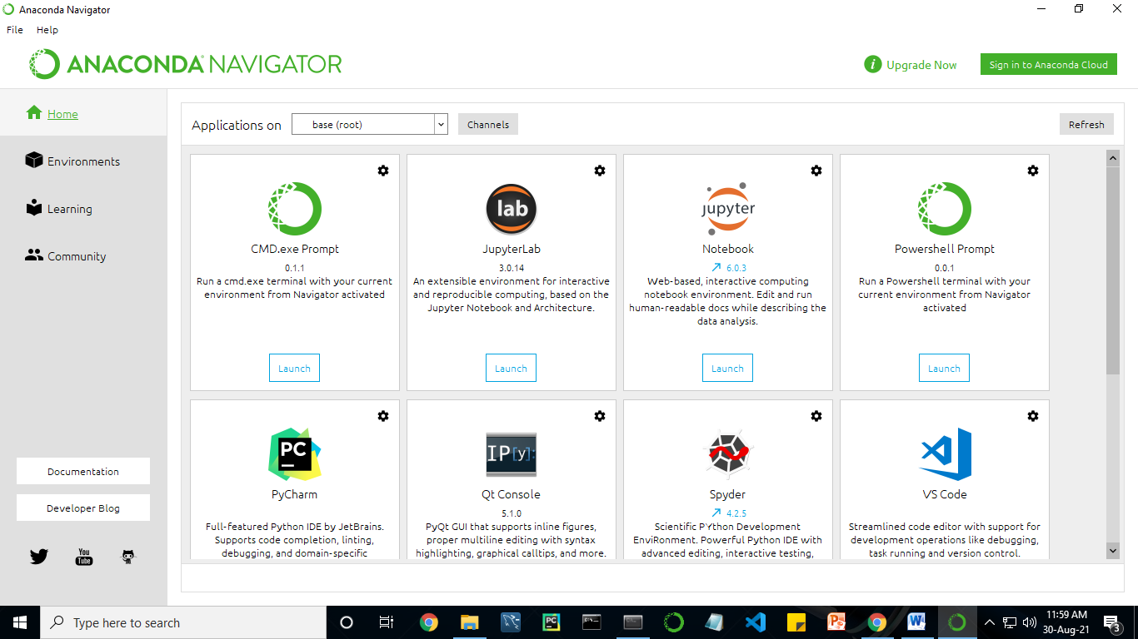

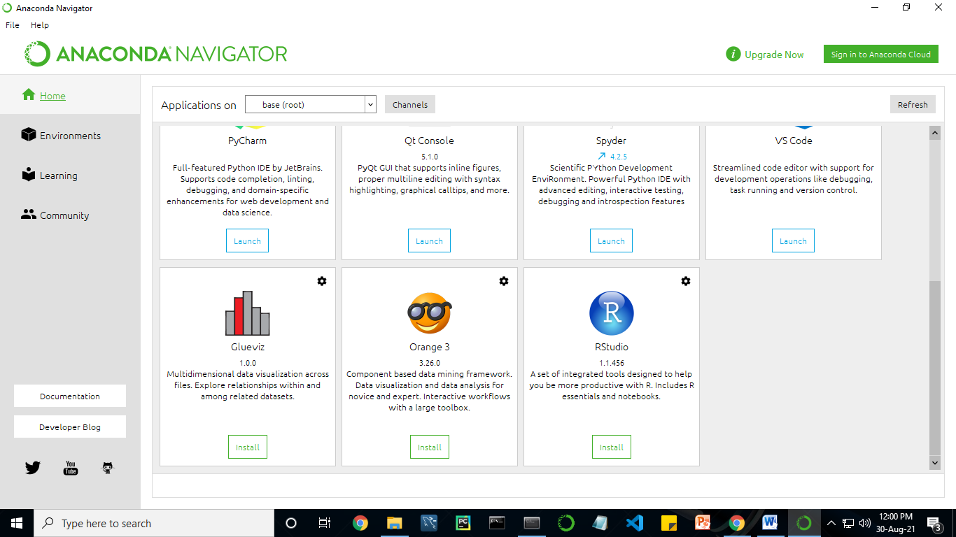

Anaconda Navigator is a desktop graphical user interface (GUI) included in Anaconda distribution.

Navigator allows you to launch common Python programs and easily manage conda packages, environments, and channels without using command-line commands. Navigator can search for packages on Anaconda Cloud or in a local Anaconda Repository.

Anaconda comes with many built-in packages that you can easily find with conda list on your anaconda prompt. As it has lots of packages (many of which are rarely used), it requires lots of space and time as well. If you have enough space, time and do not want to burden yourself to install small utilities like JSON, YAML, you better go for Anaconda.

**Conda :**

Conda is an open source, cross-platform, language-agnostic package manager and environment management systemthat installs, runs, and updates packages and their dependencies. It was created for Python programs, but it can package and distribute software for any language (e.g., R), including multi-language projects. The conda package and environment manager is included in all versions of Anaconda, Miniconda, and Anaconda Repository.

Anaconda is freely available, open source distribution of python and R programming languages which is used for scientific computations. If you are doing any machine learning or deep learning project then this is the best place for you. It consists of many softwares which will help you to build your machine learning project and deep learning project. These softwares have great graphical user interface and these will make your work easy to do. You can also use it to run your python script. These are the software carried by anaconda navigator.

**JUPYTER NOTEBOOK**

This website acts as “meta” documentation for the Jupyter ecosystem. It has a collection of resources to navigate the tools and communities in this ecosystem, and to help you get started.

Project Jupyter is a project and community whose goal is to "develop open-source software, open-standards, and services for interactive computing across dozens of programming languages". It was spun off from IPython in 2014 by Fernando Perez.

Notebook documents are documents produced by the [Jupyter Notebook App](https://jupyter-notebook-beginner-guide.readthedocs.io/en/latest/what_is_jupyter.html#notebook-app), which contain both computer code (e.g. python) and rich text elements (paragraph, equations, figures, links, etc…). Notebook documents are both human-readable documents containing the analysis description and the results (figures, tables, etc.) as well as executable documents which can be run to perform data analysis.

## Installation: The easiest way to install the Jupyter Notebook App is installing a scientific python distribution which also includes scientific python packages. The most common distribution is called **Anaconda**

# Running the Jupyter Notebook

## Launching Jupyter Notebook App: The [Jupyter Notebook App](https://jupyter-notebook-beginner-guide.readthedocs.io/en/latest/what_is_jupyter.html#notebook-app) can be launched by clicking on the Jupyter Notebook icon installed by Anaconda in the start menu (Windows) or by typing in a terminal (cmd on Windows): “jupyter notebook”

## This will launch a new browser window (or a new tab) showing the [Notebook Dashboard](https://jupyter-notebook-beginner-guide.readthedocs.io/en/latest/what_is_jupyter.html#dashboard), a sort of control panel that allows (among other things) to select which notebook to open.

## When started, the [Jupyter Notebook App](https://jupyter-notebook-beginner-guide.readthedocs.io/en/latest/what_is_jupyter.html#notebook-app) can access only files within its start-up folder (including any sub-folder). No configuration is necessary if you place your notebooks in your home folder or subfolders. Otherwise, you need to choose a [Jupyter Notebook App](https://jupyter-notebook-beginner-guide.readthedocs.io/en/latest/what_is_jupyter.html#notebook-app) start-up folder which will contain all the notebooks.

## Save notebooks: Modifications to the notebooks are automatically saved every few minutes. To avoid modifying the original notebook, make a copy of the notebook document (menu file -> make a copy…) and save the modifications on the copy.

## Executing a notebook: Download the notebook you want to execute and put it in your notebook folder (or a sub-folder of it).

* Launch the jupyter notebook app
* In the [Notebook Dashboard](https://jupyter-notebook-beginner-guide.readthedocs.io/en/latest/what_is_jupyter.html#dashboard) navigate to find the notebook: clicking on its name will open it in a new browser tab.
* Click on the menu Help -> User Interface Tour for an overview of the [Jupyter Notebook App](https://jupyter-notebook-beginner-guide.readthedocs.io/en/latest/what_is_jupyter.html#notebook-app) user interface.
* You can run the notebook document step-by-step (one cell a time) by pressing shift + enter.
* You can run the whole notebook in a single step by clicking on the menu Cell -> Run All.
* To restart the [kernel](https://jupyter-notebook-beginner-guide.readthedocs.io/en/latest/what_is_jupyter.html#kernel) (i.e. the computational engine), click on the menu Kernel -> Restart. This can be useful to start over a computation from scratch (e.g. variables are deleted, open files are closed, etc…).

[**Purpose**](https://www.google.com/search?q=project+jupyter+purpose&sa=X&ved=2ahUKEwin49vtmdjyAhXx4zgGHXSOCuwQ6BMoADAkegQINxAC&cshid=1630307847256010)**:** To support [interactive](https://www.google.com/search?q=interactive&stick=H4sIAAAAAAAAAONgVuLUz9U3MM0uyYpfxMqdmVeSWpSYXJJZlgoApkTFPhsAAAA&sa=X&ved=2ahUKEwin49vtmdjyAhXx4zgGHXSOCuwQmxMoATAkegQINxAD&cshid=1630307847256010) data science and scientific computing across all programming languages.

**File Extension:** An **IPYNB** file is a notebook document created by Jupyter Notebook, an interactive computational environment that helps scientists manipulate and analyze data using Python.

**JUPYTER Notebook App:**

The Jupyter Notebook App is a server-client application that allows editing and running [notebook documents](https://jupyter-notebook-beginner-guide.readthedocs.io/en/latest/what_is_jupyter.html#notebook-document) via a web browser.

The Jupyter Notebook App can be executed on a local desktop requiring no internet access (as described in this document) or can be installed on a remote server and accessed through the internet.

In addition to displaying/editing/running notebook documents, the Jupyter Notebook App has a “Dashboard” ([Notebook Dashboard](https://jupyter-notebook-beginner-guide.readthedocs.io/en/latest/what_is_jupyter.html#dashboard)), a “control panel” showing local files and allowing to open notebook documents or shutting down their [kernels](https://jupyter-notebook-beginner-guide.readthedocs.io/en/latest/what_is_jupyter.html#kernel).

## [Kernel](https://jupyter-notebook-beginner-guide.readthedocs.io/en/latest/what_is_jupyter.html#id7): A notebook kernel is a “computational engine” that executes the code contained in a [Notebook document](https://jupyter-notebook-beginner-guide.readthedocs.io/en/latest/what_is_jupyter.html#notebook-document). The ipython kernel, referenced in this guide, executes python code. Kernels for many other languages exist ([official kernels](http://jupyter.readthedocs.org/en/latest/#kernels)).

When you open a [Notebook document](https://jupyter-notebook-beginner-guide.readthedocs.io/en/latest/what_is_jupyter.html#notebook-document), the associated kernel is automatically launched. When the notebook is executed (either cell-by-cell or with menu Cell -> Run All), the kernel performs the computation and produces the results.

Depending on the type of computations, the kernel may consume significant CPU and RAM. Note that the RAM is not released until the kernel is shut-down

## [Notebook Dashboard](https://jupyter-notebook-beginner-guide.readthedocs.io/en/latest/what_is_jupyter.html#id8): The Notebook Dashboard is the component which is shown first when you launch [Jupyter Notebook App](https://jupyter-notebook-beginner-guide.readthedocs.io/en/latest/what_is_jupyter.html#notebook-app). The Notebook Dashboard is mainly used to open [notebook documents](https://jupyter-notebook-beginner-guide.readthedocs.io/en/latest/what_is_jupyter.html#notebook-document), and to manage the running [kernels](https://jupyter-notebook-beginner-guide.readthedocs.io/en/latest/what_is_jupyter.html#kernel) (visualize and shutdown).

The Notebook Dashboard has other features similar to a file manager, namely navigating folders and renaming/deleting files

**Working Process:**

* Download and install anaconda and get the most useful package for machine learning in Python.
* Load a dataset and understand its structure using statistical summaries and data visualization.
* Machine learning models, pick the best and build confidence that the accuracy is reliable.

Python is a popular and powerful interpreted language. Unlike R, Python is a complete language and platform that you can use for both research and development and developing production systems. There are also a lot of modules and libraries to choose from, providing multiple ways to do each task. It can feel overwhelming.

The best way to get started using Python for machine learning is to complete a project.

* It will force you to install and start the Python interpreter (at the very least).
* It will give you a bird’s eye view of how to step through a small project.
* It will give you confidence, maybe to go on to your own small projects.

When you are applying machine learning to your own datasets, you are working on a project. A machine learning project may not be linear, but it has a number of well-known steps:

* Define Problem.
* Prepare Data.
* Evaluate Algorithms.
* Improve Results.
* Present Results.

The best way to really come to terms with a new platform or tool is to work through a machine learning project end-to-end and cover the key steps. Namely, from loading data, summarizing data, evaluating algorithms and making some predictions.

Here is an overview of what we are going to cover:

1. Installing the Python anaconda platform.
2. Loading the dataset.
3. Summarizing the dataset.
4. Visualizing the dataset.
5. Evaluating some algorithms.
6. Making some predictions.

**PYTHON**

**Introduction:**

Python is an [interpreted](https://en.wikipedia.org/wiki/Interpreted_language) [high-level](https://en.wikipedia.org/wiki/High-level_programming_language) [general-purpose programming language](https://en.wikipedia.org/wiki/General-purpose_programming_language). Its design philosophy emphasizes [code readability](https://en.wikipedia.org/wiki/Code_readability) with its use of [significant indentation](https://en.wikipedia.org/wiki/Off-side_rule). Its [language constructs](https://en.wikipedia.org/wiki/Language_construct) as well as its [object-oriented](https://en.wikipedia.org/wiki/Object-oriented_programming) approach aim to help [programmers](https://en.wikipedia.org/wiki/Programmers) write clear, logical code for small and large-scale projects.

Python is [dynamically-typed](https://en.wikipedia.org/wiki/Type_system#DYNAMIC) and [garbage-collected](https://en.wikipedia.org/wiki/Garbage_collection_(computer_science)). It supports multiple [programming paradigms](https://en.wikipedia.org/wiki/Programming_paradigms), including [structured](https://en.wikipedia.org/wiki/Structured_programming) (particularly, [procedural](https://en.wikipedia.org/wiki/Procedural_programming)), object-oriented and [functional programming](https://en.wikipedia.org/wiki/Functional_programming). It is often described as a "batteries included" language due to its comprehensive [standard library](https://en.wikipedia.org/wiki/Standard_library).

[Guido van Rossum](https://en.wikipedia.org/wiki/Guido_van_Rossum) began working on Python in the late 1980s, as a successor to the [ABC programming language](https://en.wikipedia.org/wiki/ABC_(programming_language)), and first released it in 1991 as Python 0.9.0. Python 2.0 was released in 2000 and introduced new features, such as [list comprehensions](https://en.wikipedia.org/wiki/List_comprehension) and a garbage collection system using [reference counting](https://en.wikipedia.org/wiki/Reference_counting). Python 3.0 was released in 2008 and was a major revision of the language that is not completely [backward-compatible](https://en.wikipedia.org/wiki/Backward_compatibility). Python 2 was discontinued with version 2.7.18 in 2020.

Python consistently ranks as one of the most popular programming languages

**History:**

Python was conceived in the late 1980s by [Guido van Rossum](https://en.wikipedia.org/wiki/Guido_van_Rossum) at [Centrum Wiskunde & Informatica](https://en.wikipedia.org/wiki/Centrum_Wiskunde_%26_Informatica) (CWI) in the [Netherlands](https://en.wikipedia.org/wiki/Netherlands) as a successor to [ABC programming language](https://en.wikipedia.org/wiki/ABC_(programming_language)), which was inspired by [SETL](https://en.wikipedia.org/wiki/SETL),  capable of [exception handling](https://en.wikipedia.org/wiki/Exception_handling) and interfacing with the [Amoeba](https://en.wikipedia.org/wiki/Amoeba_(operating_system)) operating system. Its implementation began in December 1989.  Van Rossum shouldered sole responsibility for the project, as the lead developer, until 12 July 2018, when he announced his "permanent vacation" from his responsibilities as Python's [Benevolent Dictator for Life](https://en.wikipedia.org/wiki/Benevolent_Dictator_For_Life), a title the Python community bestowed upon him to reflect his long-term commitment as the project's chief decision-maker. In January 2019, active Python core developers elected a 5-member "Steering Council" to lead the project.  As of 2021, the current members of this council are Barry Warsaw, Brett Cannon, Carol Willing, Thomas Wouters, and Pablo Galindo Salgado.

Python 2.0 was released on 16 October 2000, with many major new features, including a [cycle-detecting](https://en.wikipedia.org/wiki/Cycle_detection) [garbage collector](https://en.wikipedia.org/wiki/Garbage_collection_(computer_science)) and support for [Unicode](https://en.wikipedia.org/wiki/Unicode).

Python 3.0 was released on 3 December 2008. It was a major revision of the language that is not completely [backward-compatible](https://en.wikipedia.org/wiki/Backward_compatibility). Many of its major features were [backported](https://en.wikipedia.org/wiki/Backporting) to Python 2.6.x and 2.7.x version series. Releases of Python 3 include the 2 to 3 utility, which automates (at least partially) the translation of Python 2 code to Python 3.

Python 2.7's [end-of-life](https://en.wikipedia.org/wiki/End-of-life_(product)) date was initially set at 2015 then postponed to 2020 out of concern that a large body of existing code could not easily be forward-ported to Python 3. No more security patches or other improvements will be released for it. With Python 2's [end-of-life](https://en.wikipedia.org/wiki/End-of-life_(product)), only Python 3.6.x and later are supported.

Python 3.9.2 and 3.8.8 were expeditedas all versions of Python (including 2.7) had security issues, leading to possible [remote code execution](https://en.wikipedia.org/wiki/Remote_code_execution) and [web cache poisoning](https://en.wikipedia.org/wiki/Cache_poisoning).

**Design Philosophy & Feature**

Python is a [multi-paradigm programming language](https://en.wikipedia.org/wiki/Multi-paradigm_programming_language). [Object-oriented programming](https://en.wikipedia.org/wiki/Object-oriented_programming) and [structured programming](https://en.wikipedia.org/wiki/Structured_programming) are fully supported, and many of its features support functional programming and [aspect-oriented programming](https://en.wikipedia.org/wiki/Aspect-oriented_programming) (including by [meta-programming](https://en.wikipedia.org/wiki/Metaprogramming) and [meta-objects](https://en.wikipedia.org/wiki/Metaobject) (magic methods)). Many other paradigms are supported via extensions, including [design by contract](https://en.wikipedia.org/wiki/Design_by_contract) and [logic programming](https://en.wikipedia.org/wiki/Logic_programming).

Python uses [dynamic typing](https://en.wikipedia.org/wiki/Dynamic_typing) and a combination of [reference counting](https://en.wikipedia.org/wiki/Reference_counting) and a cycle-detecting garbage collector for [memory management](https://en.wikipedia.org/wiki/Memory_management). It also features dynamic [name resolution](https://en.wikipedia.org/wiki/Name_resolution_(programming_languages)) ([late binding](https://en.wikipedia.org/wiki/Late_binding)), which binds method and variable names during program execution.

Python's design offers some support for functional programming in the [Lisp](https://en.wikipedia.org/wiki/Lisp_(programming_language)) tradition. It has filter, map and reduce functions; [list comprehensions](https://en.wikipedia.org/wiki/List_comprehension), [dictionaries](https://en.wikipedia.org/wiki/Associative_array), sets, and [generator](https://en.wikipedia.org/wiki/Generator_(computer_programming)) expressions. The standard library has two modules (itertools and functools) that implement functional tools borrowed from [Haskell](https://en.wikipedia.org/wiki/Haskell_(programming_language)) and [Standard ML](https://en.wikipedia.org/wiki/Standard_ML).

The language's core philosophy is summarized in the document The [Zen of Python](https://en.wikipedia.org/wiki/Zen_of_Python) (PEP 20), which includes [aphorisms](https://en.wikipedia.org/wiki/Aphorism) such as:

* Beautiful is better than ugly.
* Explicit is better than implicit.
* Simple is better than complex.
* Complex is better than complicated.
* Readability counts.

Rather than having all of its functionality built into its core, Python was designed to be highly [extensible](https://en.wikipedia.org/wiki/Extensibility) (with modules). This compact modularity has made it particularly popular as a means of adding programmable interfaces to existing applications. Van Rossum's vision of a small core language with a large standard library and easily extensible interpreter stemmed from his frustrations with [ABC](https://en.wikipedia.org/wiki/ABC_(programming_language)), which espoused the opposite approach.

Python strives for a simpler, less-cluttered syntax and grammar while giving developers a choice in their coding methodology. In contrast to [Perl](https://en.wikipedia.org/wiki/Perl)'s "[there is more than one way to do it](https://en.wikipedia.org/wiki/There_is_more_than_one_way_to_do_it)" motto, Python embraces a "there should be one— and preferably only one —obvious way to do it" design philosophy. [Alex Martelli](https://en.wikipedia.org/wiki/Alex_Martelli), a [Fellow](https://en.wikipedia.org/wiki/Fellow) at the [Python Software Foundation](https://en.wikipedia.org/wiki/Python_Software_Foundation) and Python book author, writes that "To describe something as 'clever' is not considered a compliment in the Python culture."

Python's developers strive to avoid [premature optimization](https://en.wikipedia.org/wiki/Premature_optimization), and reject patches to non-critical parts of the [C-Python](https://en.wikipedia.org/wiki/CPython) reference implementation that would offer marginal increases in speed at the cost of clarity. When speed is important, a Python programmer can move time-critical functions to extension modules written in languages such as C, or use [PyPy](https://en.wikipedia.org/wiki/PyPy), a [just-in-time compiler](https://en.wikipedia.org/wiki/Just-in-time_compilation). [Cython](https://en.wikipedia.org/wiki/Cython) is also available, which translates a Python script into C and makes direct C-level API calls into the Python interpreter.

Python's developers aim to keep the language fun to use. This is reflected in its name a tribute to the British comedy group [Monty Python](https://en.wikipedia.org/wiki/Monty_Python) and in occasionally playful approaches to tutorials and reference materials, such as examples that refer to spam and eggs (a reference to a [Monty Python sketch](https://en.wikipedia.org/wiki/Spam_(Monty_Python))) instead of the standard [foo and bar](https://en.wikipedia.org/wiki/Foobar).

A common [neologism](https://en.wikipedia.org/wiki/Neologism) in the Python community is pythonic, which can have a wide range of meanings related to program style. To say that code is pythonic is to say that it uses Python idioms well, that it is natural or shows fluency in the language, and that it conforms to Python's minimalist philosophy and emphasis on readability. In contrast, code that is difficult to understand or reads like a rough transcription from another programming language is called unpythonic.

Users and admirers of Python, especially those considered knowledgeable or experienced, are often referred to as Pythonistas

**Syntax and Semantics :**

Python is meant to be an easily readable language. Its formatting is visually uncluttered, and it often uses English keywords where other languages use punctuation. Unlike many other languages, it does not use [curly brackets](https://en.wikipedia.org/wiki/Curly_bracket_programming_language) to delimit blocks, and semicolons after statements are allowed but are rarely, if ever, used. It has fewer syntactic exceptions and special cases than [C](https://en.wikipedia.org/wiki/C_(programming_language)) or [Pascal](https://en.wikipedia.org/wiki/Pascal_(programming_language)).

**Indentation :**

Main article: [Python syntax and semantics & Indentation](https://en.wikipedia.org/wiki/Python_syntax_and_semantics#Indentation)

Python uses [whitespace](https://en.wikipedia.org/wiki/Whitespace_character) indentation, rather than [curly brackets](https://en.wikipedia.org/wiki/Curly_bracket_programming_language) or keywords, to delimit [blocks](https://en.wikipedia.org/wiki/Block_(programming)). An increase in indentation comes after certain statements; a decrease in indentation signifies the end of the current block. Thus, the program's visual structure accurately represents the program's semantic structure. This feature is sometimes termed the [off-side rule](https://en.wikipedia.org/wiki/Off-side_rule), which some other languages share, but in most languages indentation does not have any semantic meaning. The recommended indent size is four spaces.

**Statements and control flow:**

Python's [statements](https://en.wikipedia.org/wiki/Statement_(computer_science)) include:

* The [assignment](https://en.wikipedia.org/wiki/Assignment_(computer_science)) statement, using a single equals sign =.
* The if statement, which conditionally executes a block of code, along with else and elif (a contraction of else-if).
* The for statement, which iterates over an iterable object, capturing each element to a local variable for use by the attached block.
* The while statement, which executes a block of code as long as its condition is true.
* The Try statement, which allows exceptions raised in its attached code block to be caught and handled by except clauses; it also ensures that clean-up code in a finally block will always be run regardless of how the block exits.
* The raise statement, used to raise a specified exception or re-raise a caught exception.
* The class statement, which executes a block of code and attaches its local namespace to a [class](https://en.wikipedia.org/wiki/Class_(computer_science)), for use in object-oriented programming.
* The def statement, which defines a [function](https://en.wikipedia.org/wiki/Function_(computing)) or [method](https://en.wikipedia.org/wiki/Method_(computing)).
* The with statement, which encloses a code block within a context manager (for example, acquiring a [lock](https://en.wikipedia.org/wiki/Lock_(computer_science)) before the block of code is run and releasing the lock afterwards, or opening a [file](https://en.wikipedia.org/wiki/Computer_file) and then closing it), allowing [resource-acquisition-is-initialization](https://en.wikipedia.org/wiki/Resource_acquisition_is_initialization) (RAII) - like behavior and replaces a common try/finally idiom.
* The break statement, exits from a loop.
* The continue statement, skips this iteration and continues with the next item.
* The del statement, removes a variable, which means the reference from the name to the value is deleted and trying to use that variable will cause an error. A deleted variable can be reassigned.
* The pass statement, which serves as a [NOP](https://en.wikipedia.org/wiki/NOP_(code)). It is syntactically needed to create an empty code block.
* The assert statement, used during debugging to check for conditions that should apply.
* The yield statement, which returns a value from a [generator](https://en.wikipedia.org/wiki/Generator_(computer_programming)#Python) function and yield is also an operator. This form is used to implement [co-routines](https://en.wikipedia.org/wiki/Coroutine).
* The return statement, used to return a value from a function.
* The import statement, which is used to import modules whose functions or variables can be used in the current program.

The assignment statement (=) operates by binding a name as a [reference](https://en.wikipedia.org/wiki/Pointer_(computer_programming)) to a separate, dynamically-allocated [object](https://en.wikipedia.org/wiki/Object_(computer_science)). Variables may be subsequently rebound at any time to any object. In Python, a variable name is a generic reference holder and does not have a fixed [data type](https://en.wikipedia.org/wiki/Type_system) associated with it. However, at a given time, a variable will refer to some object, which will have a type. This is referred to as [dynamic typing](https://en.wikipedia.org/wiki/Dynamic_type) and is contrasted with [statically-typed](https://en.wikipedia.org/wiki/Statically-typed) programming languages, where each variable may only contain values of a certain type.

Python does not support [tail call](https://en.wikipedia.org/wiki/Tail_call) optimization or [first-class continuations](https://en.wikipedia.org/wiki/First-class_continuations), and, according to Guido van Rossum, it never will.[[80]](https://en.wikipedia.org/wiki/Python_(programming_language)#cite_note-AutoNT-55-80)[[81]](https://en.wikipedia.org/wiki/Python_(programming_language)#cite_note-AutoNT-56-81) However, better support for [co-routine](https://en.wikipedia.org/wiki/Coroutine)-like functionality is provided, by extending Python's [generators](https://en.wikipedia.org/wiki/Generator_(computer_programming)). Before 2.5, generators were [lazy](https://en.wikipedia.org/wiki/Lazy_evaluation) [iterators](https://en.wikipedia.org/wiki/Iterator); information was passed uni-directionally out of the generator. From Python 2.5, it is possible to pass information back into a generator function, and from Python 3.3, the information can be passed through multiple stack levels.

**Expressions** :

Some Python [expressions](https://en.wikipedia.org/wiki/Expression_(computer_science)) are similar to those found in languages such as C and [Java](https://en.wikipedia.org/wiki/Java_(programming_language)), while some are not:

* Addition, subtraction, and multiplication are the same, but the behaviour of division differs. There are two types of divisions in Python. They are floor division (or integer division) // and floating-point/division. Python also uses the ** operator for exponentiation.
* From Python 3.5, the new @ infix operator was introduced. It is intended to be used by libraries such as [NumPy](https://en.wikipedia.org/wiki/NumPy) for [matrix multiplication](https://en.wikipedia.org/wiki/Matrix_multiplication).
* From Python 3.8, the syntax: =, called the 'walrus operator' was introduced. It assigns values to variables as part of a larger expression.
* In Python, == compares by value, versus Java, which compares numerics by value and objects by reference. (Value comparisons in Java on objects can be performed with the equals () method.) Python's is operator may be used to compare object identities (comparison by reference). In Python, comparisons may be chained, for example A<=B<=C.
* Python uses the words and, or, not for or its boolean operators rather than the symbolic &&, ||,! Used in Java and C.
* Python has a type of expression termed a [list comprehension](https://en.wikipedia.org/wiki/List_comprehension#Python) as well as a more general expression termed a [generator](https://en.wikipedia.org/wiki/Generator_(computer_programming)) expression.
* [Anonymous functions](https://en.wikipedia.org/wiki/Anonymous_function) are implemented using [lambda expressions](https://en.wikipedia.org/wiki/Lambda_(programming)); however, these are limited in that the body can only be one expression.
* Conditional expressions in Python are written as x if c else y (different in order of operands from the c ? x : y operator common to many other languages).
* Python makes a distinction between [lists](https://en.wikipedia.org/wiki/List_(computer_science)) and [tuples](https://en.wikipedia.org/wiki/Tuple). Lists are written as [1, 2, 3], are mutable, and cannot be used as the keys of dictionaries (dictionary keys must be [immutable](https://en.wikipedia.org/wiki/Immutable) in Python). Tuples are written as (1, 2, 3), are immutable and thus can be used as the keys of dictionaries, provided all elements of the tuple are immutable. The + operator can be used to concatenate two tuples, which does not directly modify their contents, but rather produces a new tuple containing the elements of both provided tuples. Thus, given the variable t initially equal to (1, 2, 3), executing t = t + (4, 5) first evaluates t + (4, 5), which yields (1, 2, 3, 4, 5), which is then assigned back to t, thereby effectively "modifying the contents" of t, while conforming to the immutable nature of tuple objects. Parentheses are optional for tuples in unambiguous contexts.
* Python features sequence unpacking wherein multiple expressions, each evaluating to anything that can be assigned to (a variable, a writable property, etc.), are associated in an identical manner to that forming tuple literals and, as a whole, are put on the left-hand side of the equal sign in an assignment statement. The statement expects an iterable object on the right-hand side of the equal sign that produces the same number of values as the provided writable expressions when iterated through and will iterate through it, assigning each of the produced values to the corresponding expression on the left.
* Python has a "string format" operator %. This functions analogously ton printf format strings in C, e.g. “spam=%s eggs=%d” % (“blah”,2) evaluates to “spam=blah eggs=2”. In Python 3 and 2.6+, this was supplemented by the format() method of the str class, e.g. “spam={0} eggs={1}”.format(“blah”,2). Python 3.6 added "f-strings": blah = “blah”; eggs = 2; f‘spam={blah} eggs={eggs}’
* Strings in Python can be [concatenated](https://en.wikipedia.org/wiki/Concatenation), by "adding" them (same operator as for adding integers and floats). E.g. “spam” + “eggs” returns “spameggs”. Even if your strings contain numbers, they are still added as strings rather than integers. E.g. “2” + “2” returns “2”.
* Python has various kinds of [string literals](https://en.wikipedia.org/wiki/String_literal):
  + Strings delimited by single or double quote marks. Unlike in [Unix shells](https://en.wikipedia.org/wiki/Unix_shell), [Perl](https://en.wikipedia.org/wiki/Perl) and Perl-influenced languages, single quote marks and double quote marks function identically. Both kinds of string use the backslash (\) as an [escape character](https://en.wikipedia.org/wiki/Escape_character). [String interpolation](https://en.wikipedia.org/wiki/String_interpolation) became available in Python 3.6 as "formatted string literals".
  + Triple-quoted strings, which begin and end with a series of three single or double quote marks. They may span multiple lines and function like [here documents](https://en.wikipedia.org/wiki/Here_document) in shells, Perl and [Ruby](https://en.wikipedia.org/wiki/Ruby_(programming_language)).
  + [Raw string](https://en.wikipedia.org/wiki/Raw_string) varieties, denoted by prefixing the string literal with an r. Escape sequences are not interpreted; hence raw strings are useful where literal backslashes are common, such as [regular expressions](https://en.wikipedia.org/wiki/Regular_expression) and [Windows](https://en.wikipedia.org/wiki/Microsoft_Windows)-style paths. Compare "@-quoting" in [C#](https://en.wikipedia.org/wiki/C_Sharp_(programming_language)).
* Python has [array index](https://en.wikipedia.org/wiki/Array_index) and [array slicing](https://en.wikipedia.org/wiki/Array_slicing) expressions on lists, denoted as a[Key], a[start:stop] or a[start:stop:step]. Indexes are [zero-based](https://en.wikipedia.org/wiki/Zero-based_numbering), and negative indexes are relative to the end. Slices take elements from the start index up to, but not including, the stop index. The third slice parameter, called step or stride, allows elements to be skipped and reversed. Slice indexes may be omitted, for example a[:] returns a copy of the entire list. Each element of a slice is a [shallow copy](https://en.wikipedia.org/wiki/Shallow_copy).

In Python, a distinction between expressions and statements is rigidly enforced, in contrast to languages such as [Common Lisp](https://en.wikipedia.org/wiki/Common_Lisp), [Scheme](https://en.wikipedia.org/wiki/Scheme_(programming_language)), or [Ruby](https://en.wikipedia.org/wiki/Ruby_(programming_language)). This leads to duplicating some functionality. For example:

* [List comprehensions](https://en.wikipedia.org/wiki/List_comprehensions) vs. for-loops
* [Conditional](https://en.wikipedia.org/wiki/Conditional_(programming)) expressions vs. if blocks
* The eval() vs. exec() built-in functions (in Python 2, exec is a statement); the former is for expressions, the latter is for statements.

Statements cannot be a part of an expression, so list and other comprehensions or [lambda expressions](https://en.wikipedia.org/wiki/Lambda_(programming)), all being expressions, cannot contain statements. A particular case of this is that an assignment statement such as a=1 cannot form part of the conditional expression of a conditional statement. This has the advantage of avoiding a classic C error of mistaking an assignment operator = for an equality operator == in conditions: if (c==1) {…} is syntactically valid (but probably unintended) C code but if c=1: … causes a syntax error in Python.

**Methods** :

[Methods](https://en.wikipedia.org/wiki/Method_(programming)) on objects are [functions](https://en.wikipedia.org/wiki/Function_(programming)) attached to the object's class; the syntax instance. method(argument) is, for normal methods and functions, [syntactic sugar](https://en.wikipedia.org/wiki/Syntactic_sugar) for Class. method(instance, argument). Python methods have an explicit self parameter access [instance data](https://en.wikipedia.org/wiki/Instance_data), in contrast to the implicit self (or this) in some other object-oriented programming languages (e.g., [C++](https://en.wikipedia.org/wiki/C%2B%2B), Java, [Objective-C](https://en.wikipedia.org/wiki/Objective-C), or [Ruby](https://en.wikipedia.org/wiki/Ruby_(programming_language))). Apart from this Python also provides methods, sometimes called d-under methods due to their names beginning and ending with double-underscores, to extend the functionality of custom class to support native functions such as print, length, comparison, support for arithmetic operations, type conversion, and many more.

### Typing :

Python uses duck typing and has typed objects but un typed variable names. Type constraints are not checked at compile time; rather, operations on an object may fail, signifying that the given object is not of a suitable type. Despite being dynamically-typed, Python is strongly-typed, forbidding operations that are not well-defined (for example, adding a number to a string) rather than silently attempting to make sense of them.

Python allows programmers to define their own types using [classes](https://en.wikipedia.org/wiki/Class_(computer_science)), which are most often used for object-oriented programming. New instances of classes are constructed by calling the class (for example, Spam Class() or Eggs Class()), and the classes are instances of the meta class type (itself an instance of itself), allowing meta-programming and reflection.

Before version 3.0, Python had two kinds of classes: old-style and new-style.The syntax of both styles is the same, the difference being whether the class object is inherited from, directly or indirectly (all new-style classes inherit from object and are instances of type). In versions of Python 2 from Python 2.2 onwards, both kinds of classes can be used. Old-style classes were eliminated in Python 3.0.

The long-term plan is to support gradual typing and from Python 3.5, the syntax of the language allows specifying static types but they are not checked in the default implementation, C ,Python. An experimental optional static type checker named mypy supports compile-time type checking

**Advantages:**

* We are using the machine learning technique for getting better predictions.
* Their accuracy and performance metrics were poor.
* Deployment is done here.

**DESIGN ARCHITECTURE:**

**System Architecture:**

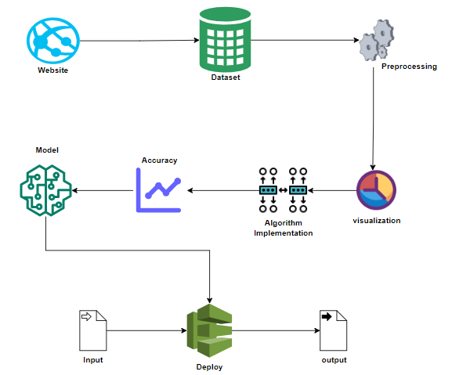

**Work flow diagram**

Source Data

Data Processing and Cleaning

Testing Dataset

Training Dataset

Classification ML Algorithms

Best Model by Accuracy

Predicting forest fires

**Use Case Diagram:**

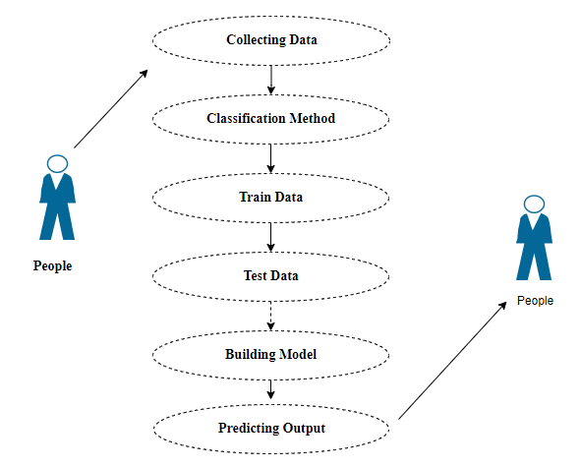

Use case diagrams are considered for high level requirement analysis of a system. So when the requirements of a system are analyzed the functionalities are captured in use cases. So, it can say that uses cases are nothing but the system functionalities written in an organized manner.

**Class Diagram**:

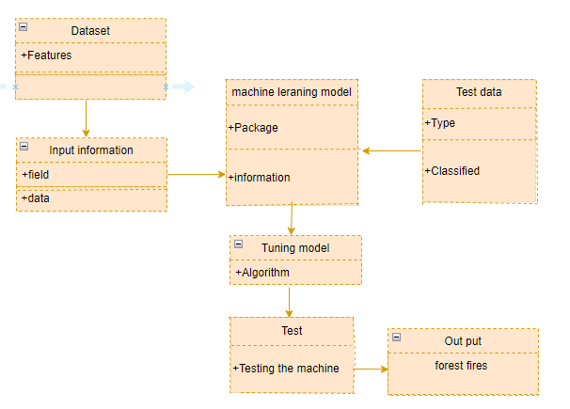

Class diagram is basically a graphical representation of the static view of the system and represents different aspects of the application. So a collection of class diagrams represent the whole system. The name of the class diagram should be meaningful to describe the aspect of the system. Each element and their relationships should be identified in advance Responsibility (attributes and methods) of each class should be clearly identified for each class minimum number of properties should be specified and because, unnecessary properties will make the diagram complicated. Use notes whenever required to describe some aspect of the diagram and at the end of the drawing it should be understandable to the developer/coder. Finally, before making the final version, the diagram should be drawn on plain paper and rework as many times as possible to make it correct.

**Activity Diagram**:

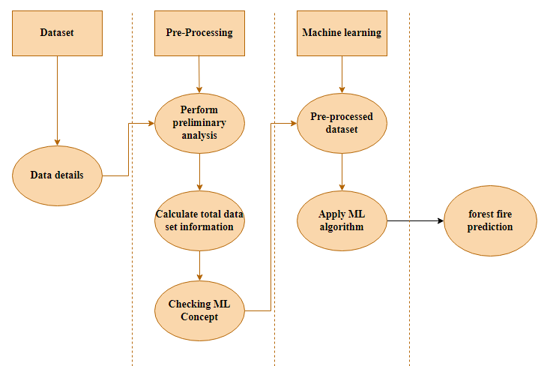

Activity is a particular operation of the system. Activity diagrams are not only used for visualizing dynamic nature of a system but they are also used to construct the executable system by using forward and reverse engineering techniques. The only missing thing in activity diagram is the message part. It does not show any message flow from one activity to another. Activity diagram is some time considered as the flow chart. Although the diagrams looks like a flow chart but it is not. It shows different flow like parallel, branched, concurrent and single.

**Sequence Diagram**:

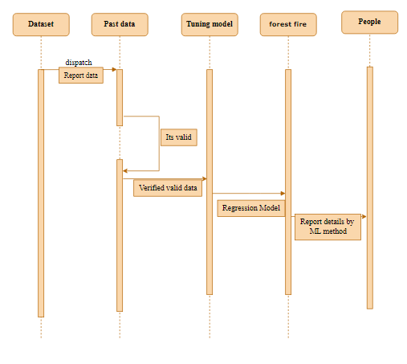

Sequence diagrams model the flow of logic within your system in a visual manner, enabling you both to document and validate your logic, and are commonly used for both analysis and design purposes. Sequence diagrams are the most popular UML artifact for dynamic modelling, which focuses on identifying the behavior within your system. Other dynamic modelling techniques include [activity diagramming](http://agilemodeling.com/artifacts/activityDiagram.htm), [communication diagramming](http://agilemodeling.com/artifacts/communicationDiagram.htm), [timing diagramming](http://agilemodeling.com/artifacts/timingDiagram.htm), and [interaction overview diagramming](http://agilemodeling.com/artifacts/interactionOverviewDiagram.htm). Sequence diagrams, along with [class diagrams](http://agilemodeling.com/artifacts/classDiagram.htm) and [physical data models](http://agiledata.org/essays/dataModeling101.html) are in my opinion the most important design-level models for modern business application development

**Entity Relationship Diagram (ERD):**

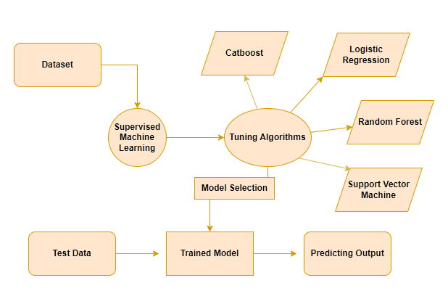

An entity relationship diagram (ERD), also known as an entity relationship model, is a graphical representation of an information system that depicts the relationships among people, objects, places, concepts or events within that system. An ERD is a [data modeling](https://searchdatamanagement.techtarget.com/definition/data-modeling) technique that can help define business processes and be used as the foundation for a [relational database](https://searchdatamanagement.techtarget.com/definition/relational-database). Entity relationship diagrams provide a visual starting point for database design that can also be used to help determine information system requirements throughout an organization. After a relational database is rolled out, an ERD can still serve as a referral point, should any debugging or business process re-engineering be needed later.

**MODULE DESCRIPTION:**

**Data Pre-processing:**

Validation techniques in machine learning are used to get the error rate of the Machine Learning (ML) model, which can be considered as close to the true error rate of the dataset. If the data volume is large enough to be representative of the population, you may not need the validation techniques. However, in real-world scenarios, to work with samples of data that may not be a true representative of the population of given dataset. To finding the missing value, duplicate value and description of data type whether it is float variable or integer. The sample of data used to provide an unbiased evaluation of a model fit on the training dataset while tuning model hyper parameters.

The evaluation becomes more biased as skill on the validation dataset is incorporated into the model configuration. The validation set is used to evaluate a given model, but this is for frequent evaluation. It as machine learning engineers use this data to fine-tune the model hyper parameters. Data collection, data analysis, and the process of addressing data content, quality, and structure can add up to a time-consuming to-do list. During the process of data identification, it helps to understand your data and its properties; this knowledge will help you choose which algorithm to use to build your model.

A number of different **data cleaning** tasks using Python’s [Pandas library](https://pandas.pydata.org/) and specifically, it focus on probably the biggest data cleaning task, **missing values** and it able to **more**[**quickly clean data**](https://www.dataoptimal.com/data-cleaning-with-python-2018/). It wants to **spend less time cleaning data**, and more time exploring and modeling.

Some of these sources are just simple random mistakes. Other times, there can be a deeper reason why data is missing. It’s important to understand these [different types of missing data](https://en.wikipedia.org/wiki/Missing_data) from a statistics point of view. The type of missing data will influence how to deal with filling in the missing values and to detect missing values, and do some basic imputation and detailed statistical approach for [dealing with missing data](https://github.com/matthewbrems/ODSC-missing-data-may-18/blob/master/Analysis%20with%20Missing%20Data.pdf). Before, joint into code, it’s important to understand the sources of missing data. Here are some typical reasons why data is missing:

* User forgot to fill in a field.
* Data was lost while transferring manually from a legacy database.
* There was a programming error.
* Users chose not to fill out a field tied to their beliefs about how the results would be used or interpreted.

Variable identification with Uni-variate, Bi-variate and Multi-variate analysis:

* import libraries for access and functional purpose and read the given dataset
* General Properties of Analyzing the given dataset
* Display the given dataset in the form of data frame
* show columns
* shape of the data frame
* To describe the data frame
* Checking data type and information about dataset
* Checking for duplicate data
* Checking Missing values of data frame
* Checking unique values of data frame
* Checking count values of data frame
* Rename and drop the given data frame
* To specify the type of values
* To create extra columns

MODULE DIAGRAM

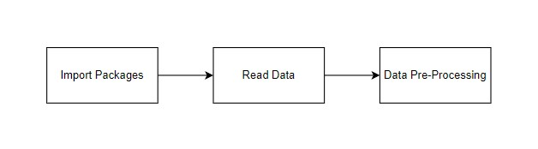

GIVEN INPUT EXPECTED OUTPUT

input : data

output : removing noisy data

**Data visualization:**

Data visualization is an important skill in applied statistics and machine learning. Statistics does indeed focus on quantitative descriptions and estimations of data. Data visualization provides an important suite of tools for gaining a qualitative understanding. This can be helpful when exploring and getting to know a dataset and can help with identifying patterns, corrupt data, outliers, and much more. With a little domain knowledge, data visualizations can be used to express and demonstrate key relationships in plots and charts that are more visceral and stakeholders than measures of association or significance. Data visualization and exploratory data analysis are whole fields themselves and it will recommend a deeper dive into some the books mentioned at the end.

Sometimes data does not make sense until it can look at in a visual form, such as with charts and plots. Being able to quickly visualize of data samples and others is an important skill both in applied statistics and in applied machine learning. It will discover the many types of plots that you will need to know when visualizing data in Python and how to use them to better understand your own data.

* How to chart time series data with line plots and categorical quantities with bar charts.
* How to summarize data distributions with histograms and box plots.

MODULE DIAGRAM

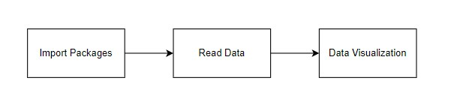

GIVEN INPUT EXPECTED OUTPUT

input : data

output : visualized data

**Algorithm implementation:**

It is important to compare the performance of multiple different machine learning algorithms consistently and it will discover to create a test harness to compare multiple different machine learning algorithms in Python with scikit-learn. It can use this test harness as a template on your own machine learning problems and add more and different algorithms to compare. Each model will have different performance characteristics. Using resampling methods like cross validation, you can get an estimate for how accurate each model may be on unseen data. It needs to be able to use these estimates to choose one or two best models from the suite of models that you have created. When have a new dataset, it is a good idea to visualize the data using different techniques in order to look at the data from different perspectives. The same idea applies to model selection. You should use a number of different ways of looking at the estimated accuracy of your machine learning algorithms in order to choose the one or two to finalize. A way to do this is to use different visualization methods to show the average accuracy, variance and other properties of the distribution of model accuracies.

In the next section you will discover exactly how you can do that in Python with scikit-learn. The key to a fair comparison of machine learning algorithms is ensuring that each algorithm is evaluated in the same way on the same data and it can achieve this by forcing each algorithm to be evaluated on a consistent test harness.

**Performance Metrics to calculate:**

**False Positives (FP):** A person who will pay predicted as defaulter. When actual class is no and predicted class is yes. E.g. if actual class says this passenger did not survive but predicted class tells you that this passenger will survive.

**False Negatives (FN):** A person who default predicted as payer. When actual class is yes but predicted class in no. E.g. if actual class value indicates that this passenger survived and predicted class tells you that passenger will die.

**True Positives (TP):** A person who will not pay predicted as defaulter. These are the correctly predicted positive values which means that the value of actual class is yes and the value of predicted class is also yes. E.g. if actual class value indicates that this passenger survived and predicted class tells you the same thing.

**True Negatives (TN):** A person who default predicted as payer. These are the correctly predicted negative values which means that the value of actual class is no and value of predicted class is also no. E.g. if actual class says this passenger did not survive and predicted class tells you the same thing.

True Positive Rate(TPR) = TP / (TP + FN)

False Positive rate(FPR) = FP / (FP + TN)

**Accuracy:** The Proportion of the total number of predictions that is correct otherwise overall how often the model predicts correctly defaulters and non-defaulters.

**Accuracy calculation:**

Accuracy = (TP + TN) / (TP + TN + FP + FN)

Accuracy is the most intuitive performance measure and it is simply a ratio of correctly predicted observation to the total observations. One may think that, if we have high accuracy then our model is best. Yes, accuracy is a great measure but only when you have symmetric datasets where values of false positive and false negatives are almost same.

**Precision:** The proportion of positive predictions that are actually correct.

Precision = TP / (TP + FP)

Precision is the ratio of correctly predicted positive observations to the total predicted positive observations. The question that this metric answer is of all passengers that labelled as survived, how many actually survived? High precision relates to the low false positive rate. We have got 0.788 precision which is pretty good.

**Recall:** The proportion of positive observed values correctly predicted. (The proportion of actual defaulters that the model will correctly predict)

Recall = TP / (TP + FN)

Recall(Sensitivity) - Recall is the ratio of correctly predicted positive observations to the all observations in actual class - yes.

**F1 Score** is the weighted average of Precision and Recall. Therefore, this score takes both false positives and false negatives into account. Intuitively it is not as easy to understand as accuracy, but F1 is usually more useful than accuracy, especially if you have an uneven class distribution. Accuracy works best if false positives and false negatives have similar cost. If the cost of false positives and false negatives are very different, it’s better to look at both Precision and Recall.

**General Formula:**

F- Measure = 2TP / (2TP + FP + FN)

**F1-Score Formula:**

F1 Score = 2*(Recall * Precision) / (Recall + Precision)

The below 4 different algorithms are compared:

* CatBoost
* SVM
* RFC
* Logistic Regression

**CatBoost:**

CatBoost is an algorithm for gradient boosting on decision trees. It is developed by Yandex researchers and engineers, and is used for search, recommendation systems, personal assistant, self-driving cars, weather prediction and many other tasks at Yandex and in other companies, including CERN, Cloudflare, Careem taxi The CatBoost algorithm is based on Gradient Descent and is a powerful technique for supervised machine learning tasks. It will be well suited to problems that involve categorical data. It is widely used for regression and classification tasks and it is also one of the most used algorithms in Kaggle .

MODULE DIAGRAM

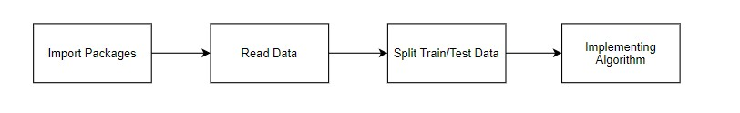

**GIVEN INPUT EXPECTED OUTPUT**

input : data

output : getting accuracy

**Support Vector Machine:**

Support Vector Machine or SVM is one of the most popular Supervised Learning algorithms, which is used for Classification as well as Regression problems. However, primarily, it is used for Classification problems in Machine Learning.

The goal of the SVM algorithm is to create the best line or decision boundary that can segregate n-dimensional space into classes so that we can easily put the new data point in the correct category in the future. This best decision boundary is called a hyperplane.

SVM chooses the extreme points/vectors that help in creating the hyperplane. These extreme cases are called as support vectors, and hence algorithm is termed as Support Vector Machine.

**MODULE DIAGRAM**



**GIVEN INPUT EXPECTED OUTPUT**

input : data

output : getting accuracy

**Random Forest Classifier:**

Random Forest is a popular machine learning algorithm that belongs to the supervised learning technique. It can be used for both Classification and Regression problems in ML. It is based on the concept of ensemble learning, which is a process of *combining multiple classifiers to solve a complex problem and to improve the performance of the model.*

As the name suggests, "Random Forest is a classifier that contains a number of decision trees on various subsets of the given dataset and takes the average to improve the predictive accuracy of that dataset." Instead of relying on one decision tree, the random forest takes the prediction from each tree and based on the majority votes of predictions, and it predicts the final output.

The greater number of trees in the forest leads to higher accuracy and prevents the problem of overfitting.

**MODULE DIAGRAM**



**GIVEN INPUT EXPECTED OUTPUT**

input : data

output : getting accuracy

) **Logistic Regression:**

Logistic regression is a supervised learning classification algorithm used to predict the probability of a target variable. The nature of target or dependent variable is dichotomous, which means there would be only two possible classes.

In simple words, the dependent variable is binary in nature having data coded as either 1 (stands for success/yes) or 0 (stands for failure/no).

Mathematically, a logistic regression model predicts P(Y=1) as a function of X. It is one of the simplest ML algorithms that can be used for various classification problems such as spam detection, Diabetes prediction, cancer detection etc.

Before diving into the implementation of logistic regression, we must be aware of the following assumptions about the same −

* In case of binary logistic regression, the target variables must be binary always and the desired outcome is represented by the factor level 1.
* There should not be any multi-collinearity in the model, which means the independent variables must be independent of each other.
* We must include meaningful variables in our model.
* We should choose a large sample size for logistic regression.

MODULE DIAGRAM



GIVEN INPUT EXPECTED OUTPUT

input: data

output: getting accuracy

**Deployment:**

**Deploying the model in Django Framework and predicting output**

In this module the trained machine learning model is converted into pickle data format file (.pkl file) which is then deployed in our django framework for providing better user interface and predicting the output of which crop suits better for the soil we selected.

MODULE DIAGRAM

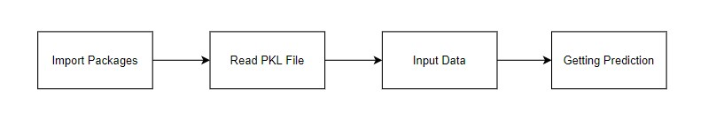

GIVEN INPUT EXPECTED OUTPUT

input : data values

output : predicting output

Django (Web FrameWork) :

Django is an extremely popular and fully featured server-side web framework, written in Python. This module shows you why Django is one of the most popular web server frameworks, how to set up a development environment, and how to start using it to create your own web applications. In this first Django article we answer the question "What is Django?" and give you an overview of what makes this web framework special. We'll outline the main features, including some advanced functionality that we won't have time to cover in detail in this module. We'll also show you some of the main building blocks of a Django application, to give you an idea of what it can do before you set it up and start playing. Now that you know what Django is for, we'll show you how to set up and test a Django development environment on Windows, Linux (Ubuntu), and macOS — whatever common operating system you are using, this article should give you what you need to be able to start developing Django apps. Django is a high-level Python web framework that enables rapid development of secure and maintainable websites. Built by experienced developers, Django takes care of much of the hassle of web development, so you can focus on writing your app without needing to reinvent the wheel.

Django follows the "Batteries included" philosophy and provides almost everything developers might want to do "out of the box". Because everything you need is part of the one "product", it all works seamlessly together, follows consistent design principles, and has extensive and up-to-date documentation.

Django can be (and has been) used to build almost any type of website — from content management systems and wikis, through to social networks and news sites. It can work with any client-side framework, and can deliver content in almost any format (including HTML, RSS feeds, JSON, XML, etc). The site you are currently reading is built with Django!

Internally, while it provides choices for almost any functionality you might want (e.g. several popular databases, templating engines, etc.), it can also be extended to use other components if needed.

•Django helps developers avoid many common security mistakes by providing a framework that has been engineered to "do the right things" to protect the website automatically. For example, Django provides a secure way to manage user accounts and passwords, avoiding common mistakes like putting session information in cookies where it is vulnerable (instead cookies just contain a key, and the actual data is stored in the database) or directly storing passwords rather than a password hash.

A password hash is a fixed-length value created by sending the password through a cryptographic hash function. Django can check if an entered password is correct by running it through the hash function and comparing the output to the stored hash value. However due to the "one-way" nature of the function, even if a stored hash value is compromised it is hard for an attacker to work out the original password.

Django enables protection against many vulnerabilities by default, including SQL injection, cross-site scripting, cross-site request forgery and clickjacking (see Website security for more details of such attacks).

Django uses a component-based “shared-nothing” architecture (each part of the architecture is independent of the others, and can hence be replaced or changed if needed). Having a clear separation between the different parts means that it can scale for increased traffic by adding hardware at any level: caching servers, database servers, or application servers. Some of the busiest sites have successfully scaled Django to meet their demands (e.g. Instagram and Disqus, to name just two).

Django code is written using design principles and patterns that encourage the creation of maintainable and reusable code. In particular, it makes use of the Don't Repeat Yourself (DRY) principle so there is no unnecessary duplication, reducing the amount of code. Django also promotes the grouping of related functionality into reusable "applications" and, at a lower level, groups related code into modules (along the lines of the Model View Controller (MVC) pattern).

Django is written in Python, which runs on many platforms. That means that you are not tied to any particular server platform, and can run your applications on many flavours of Linux, Windows, and Mac OS X. Furthermore, Django is well-supported by many web hosting providers, who often provide specific infrastructure and documentation for hosting Django sites.

**24. HTML Introduction**

HTML stands for Hyper Text Markup Language. It is used to design web pages using a markup language. HTML is the combination of Hypertext and Markup language. Hypertext defines the link between the web pages. A markup language is used to define the text document within tag which defines the structure of web pages. This language is used to annotate (make notes for the computer) text so that a machine can understand it and manipulate text accordingly. Most markup languages (e.g. HTML) are human-readable. The language uses tags to define what manipulation has to be done on the text.

#### Basic Construction of an HTML Page

These tags should be placed underneath each other **at the top of every HTML page** that you create.

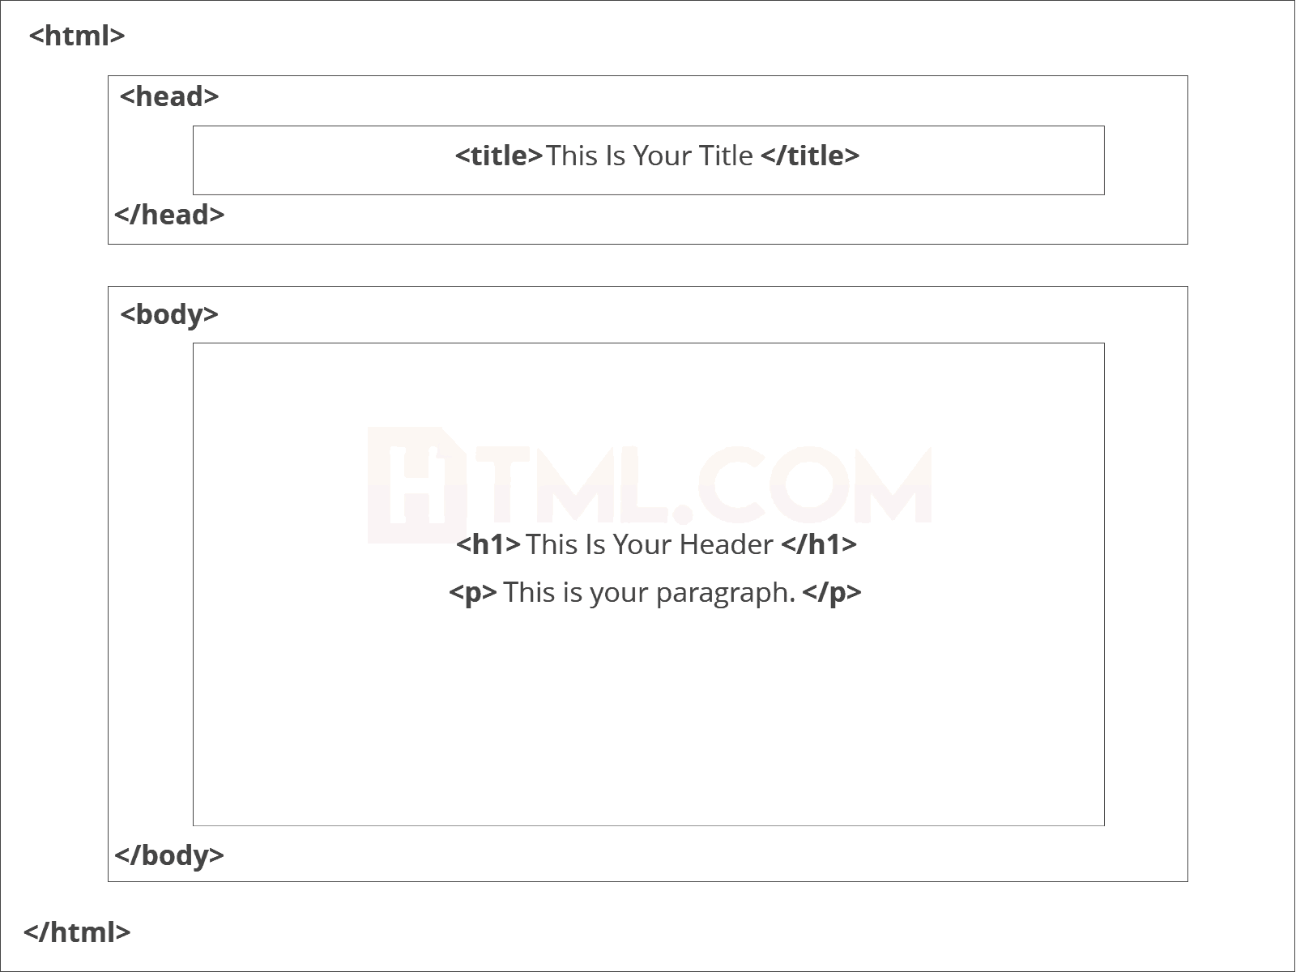

<!DOCTYPE html> — This tag**specifies the language** you will write on the page. In this case, the language is HTML 5.

<html> — This tag signals that from here on we are going to write in HTML code.

<head> — This is where all the **metadata for the page** goes — stuff mostly meant for search engines and other computer programs.

<body> — This is where the**content of the page** goes.

#### Further Tags

Inside the <head> tag, there is one tag that is always included: <title>, but there are others that are just as important:

<title>

This is where we**insert the page name** as it will appear at the top of the browser window or tab.

<meta>

This is where information about the document is stored: character encoding, name (page context), description.

**Head Tag**  
<head>

<title>My First Webpage</title>

<meta charset="UTF-8">

<meta name="description" content="This field contains information about your page. It is usually around two sentences long.">.

<meta name="author" content="Conor Sheils">

</header>

### Adding Content

Next, we will make<body> tag.

The HTML <body> is where we add the content which is designed for viewing by human eyes.

This includes **text, images, tables, forms**and everything else that we see on the internet each day.

#### Add HTML Headings To Web Page

In HTML, [headings](https://html.com/tags/heading/) are written in the following elements:

* <h1>
* <h2>
* <h3>
* <h4>
* <h5>
* <h6>

As you might have guessed <h1> and <h2> should be used for the most important titles, while the remaining tags should be used for sub-headings and less important text.

**Search engine bots use this order**when deciphering which information is most important on a page.

##### Creating Your Heading

Let’s try it out. On a new line in the HTML editor, type:

<h1> Welcome To My Page </h1>

And hit save. We will save this file as “index.html” in a new folder called “my webpage.”

**Add Text In HTML**

Adding text to our HTML page is simple using an element opened with the tag <p> which **creates a new paragraph**. We place all of our regular text inside the element <p>.

When we write text in HTML, we also have a number of other elements we can use **to control the text or make it appear in a certain way.**

#### Add Links In HTML

As you may have noticed, the internet is made up of lots of [links](https://html.com/anchors-links/).

Almost everything you click on while surfing the web is a link **takes you to another page** within the website you are visiting or to an external site.

Links are included in an attribute opened by the [**<a>**](https://html.com/tags/a/) tag. This element is the first that we’ve met which uses an attribute and so it**looks different to previously mentioned tags.**

<a href=<http://www.google.com>>Google</a>

**Image Tag**

In today’s modern digital world, [images](https://html.com/blog/100-legal-sources-free-stock-images/) are everything. The [**<**img**>**](https://html.com/tags/img/) tag has everything you need to display images on your site. Much like the <a> anchor element, <img> also contains an attribute.

The attribute features information for your computer regarding the source, height, width and alt text of the image

<img src=”yourimage.jpg” alt=”Describe the image” height=“X” width=“X”>

**25. CSS**

CSS stands for Cascading Style Sheets. It is the language for describing the presentation of Web pages, including colours, layout, and fonts, thus making our web pages presentable to the users.CSS is designed to make style sheets for the web. It is independent of HTML and can be used with any XML-based markup language. Now let’s try to break the acronym:

* Cascading: Falling of Styles
* Style: Adding designs/Styling our HTML tags
* Sheets: Writing our style in different documents

## **CSS Syntax**

Selector {

Property 1 : value;

Property 2 : value;

Property 3 : value;

}

For example:

h1

{

Color: red;

Text-align: center;

}

#unique

{

color: green;

}

* Selector: selects the element you want to target
* Always remains the same whether we apply internal or external styling
* There are few basic selectors like tags, id’s, and classes
* All forms this key-value pair
* Keys: properties(attributes) like color, font-size, background, width, height,etc
* Value: values associated with these properties

## **CSS Comment**

* Comments don’t render on the browser
* Helps to understand our code better and makes it readable.
* Helps to debug our code
* Two ways to  comment:
  + Single line

## **CSS How-To**

* There are 3 ways to write CSS in our HTML file.
  + Inline CSS
  + Internal CSS
  + External CSS
* Priority order
  + Inline > Internal > External

**Inline CSS**

* Before CSS this was the only way to apply styles
* Not an efficient way to write as it has a lot of redundancy
* Self-contained
* Uniquely applied on each element
* The idea of separation of concerns was lost
* Example:

<h3 style = “color:red”> Have a great day </h3>

<p style = “color:green”> I did this, I did that </p>

**Internal CSS**

* With the help of style tag, we can apply styles within the HTML file
* Redundancy is removed
* But the idea of separation of concerns still lost
* Uniquely applied on a single document
* Example:

<style>

H1{

Color:red;

}

</style>

<h3> Have a great day </h3>

**External CSS**

* With the help of <link> tag in the head tag, we can apply styles
* Reference is added
* File saved with .css extension
* Redundancy is removed
* The idea of separation of concerns is maintained
* Uniquely applied to each document
* Example:

<head>

<link rel= “stylesheet” type= “text/css” href= “name of the CSS file”>

</head>

h1{

color:red; //.css file

}

## **CSS Selectors**

* The selector is used to target elements and apply CSS
* Three simple selectors
  + Element Selector
  + Id Selector
  + Class Selector
* Priority of Selectors

## **CSS Colors**

* There are different colouring schemes in CSS
* **RGB**-This starts with RGB and takes 3 parameter
* **HEX**-Hex code starts with # and comprises of 6 numbers which are further divided into 3 sets
* **RGBA**-This starts with RGB and takes 4 parameter

**CSS Background**

* There are different ways by which CSS can have an effect on HTML elements
* Few of them are as follows:
  + Color – used to set the color of the background
  + Repeat – used to determine if the image has to repeat or not and if it is repeating then how it should do that
  + Image – used to set an image as the background
  + Position – used to determine the position of the image
  + Attachment – It basically helps in controlling the mechanism of scrolling.

## **CSS BoxModel**

* Every element in CSS can be represented using the BOX model
* It allows us to add a border and define space between the content
* It helps the developer to develop and manipulate the elements
* It consists of 4 edges
  + Content edge – It comprises of the actual content
  + Padding edge – It lies in between content and border edge
  + Border edge – Padding is followed by the border edge
  + Margin edge – It is an outside border and controls the margin of the element

**Conclusion:**

The analytical process started from data cleaning and processing, missing value, exploratory analysis and finally model building and evaluation. The best accuracy on Forest fire prediction set of higher accuracy score algorithm will be find out. The founded one is used in the application which can help to know in which conditions forest fire will starts.

**Future Work:**

* Deploying the project in the cloud.
* To optimize the work to implement in the IOT system.